**Ethnology of Religion**

­­**Minutes WG business meeting**

**Aberdeen June 5, 1pm**

1. The WG gave a report about its activities including the latest WG conference held in Budapest in October 2024 (Find the respective report here:<https://www.siefhome.org/downloads/wg/er/WG_EoR_Conf_Rep_24.pdf>). Conference proceedings of this conference as well as the last WG conference in Berlin 2023 are underway.
2. An election of the new WG board was held. After four years in the board, Victoria Hegner stepped down as chair, Alessandro Testa stepped down as chair, but remains in the board. Kinga Povedák as well as Thorsten Wettich were elected as co-chairs. Kamila Baraniecka-Olszewska will serve as the secretary. Clara Saraiva remains in the board.
3. A new WG conference is envisaged to be held in September 2026. The venue will be in Lisbon. The board will prepare a respective call and circulate it in January through the mailing list. A handful of new members joined the working group.

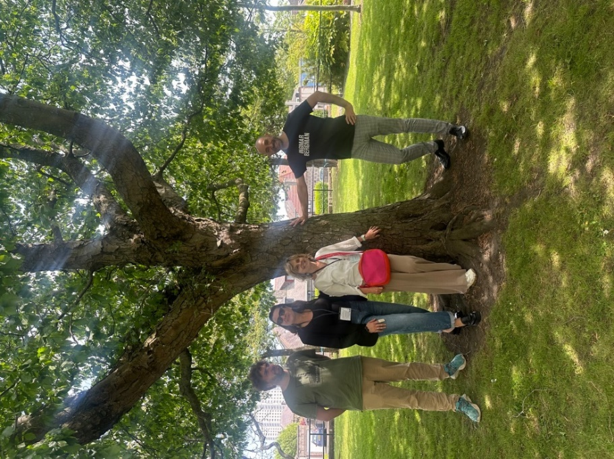

The newly elected board: Thorsten Wettich (chair), Kinga Povedák (chair), Clara Saraiva (board member), Alessandro Testa (board member). Absent: Kamila Baraniecka-Olszewska (Secretary)